**Module Title:** Advanced Integrated Computing Devices

**Module Code:** IS3S687

**Module Leader/Tutor:** Ian Fitzell

**Assessment Title:** Internet of Things (IoT) Case Study using OpenHab

**Student Name: Dilukshika Sivanathan**

**Student ID: 30073395**



Table of Contents

1. Introduction 3

Scope 3

2. Hardware/Software Inventory 4

3. MQTT 5

4. OpenHAB 6

Bindings Installed 6

Things 6

Items 6

Rules and Scripts 7

User Interface 8

Advanced Features for Future Implementation 8

Research and Alternatives 12

Conclusion 13

Appendices 14

NeoPixel Screenshots: 14

OpenHab Screenshots: 15

Reference 27

# Introduction

OpenHab One Drive Video link: [OpenHab Video](https://universityofsouthwales-my.sharepoint.com/:f:/g/personal/30073395_students_southwales_ac_uk/EgViq3vh4rFAszad5QXn7ygBGQb_Hyhvca8zPy64cgF93g?email=ian.fitzell%40southwales.ac.uk&e=WJQeJN)

There is an increasing demand in contemporary society for inventive and economically feasible technological solutions that aim to improve the quality of life of elderly individuals, especially those living in care homes. This project aims to develop a prototype based on IoT for improving safety, health monitoring, and general comfort for residents located within a residential care home setting. The proposed solution focuses on solving major challenges faced by elderly residents using affordable hardware and open-source software platforms.

This IoT prototype is expected to provide an integrated system, comprising monitoring of the environment on a range of parameters: temperature, humidity, air quality, motion detection, and UV index for warning residents and wardens in conditions that could be detrimental for going outdoors. The features help keep the residents safe, healthful, and enhance living for them.

## Scope

The prototype has been specifically designed for a single residential apartment within the care home, along with a central office for the warden. This system systematically collects and interprets sensor data to trigger automated responses or warnings when predefined thresholds are exceeded. The focus will cover:

* Monitoring indoor temperature and humidity in order to ensure a safe and comfortable environment, reducing the risk of problems such as fire, dampness, or mold.
* Monitoring air quality is essential to safeguard residents from detrimental pollution levels resulting from adjacent industrial operations.
* Ensure the safety of the residents with motion detection and alert wardens in case unusual inactivity is detected.
* UV index monitoring for over-protection against harmful sunlight during outdoor activities.

The proposed solution is a low-cost, scalable, open-source IoT system built using affordable hardware components such as ESP8266 microcontrollers, a DHT11 temperature and humidity sensor, and NeoPixel LEDs for visual alerts. It is integrated into an automation platform powered by OpenHAB and MQTT, supported with APIs like OpenWeatherMap and Air Quality API to fetch external data. Also, a user-friendly interface is intended to show critical data and notifications to wardens for real-time monitoring and fast responses.

# Hardware/Software Inventory

A detailed list of all components used:

**Hardware**

|  |  |
| --- | --- |
| Component | Purpose |
| ESP8266 | Facilitates wireless data communication between sensors and the central system. |
| DHT11 Sensor | Measures temperature and humidity. |
| PIR Sensor | Detects motion in the apartment. |
| NeoPixel LED | Visual indicators for temperature alerts. |
| Raspberry Pi | Acts as the primary controller running OpenHAB and MQTT Broker. |

**Software and Binding**

|  |  |
| --- | --- |
| Binding | Purpose |
| MQTT | Communication protocol for device-sensor interaction. |
| OpenHAB | IoT automation platform for integration and control. |
| OpenWeatherMap API | Fetches UV Index and weather data. |
| Air Quality API | Provides Air Quality Index data. |
| Astro Binding | Retrieves sun and moon information. |

# MQTT

|  |  |
| --- | --- |
| Topics List | Description |
| NeoPixel/LEDStrip/cmd | Controls the NeoPixel LED behavior. |
| Temperature | Publishes temperature readings from DHT11. |
| Humidity | Publishes humidity readings from DHT11. |
| Motion_Detected | Publishes motion detection data. |
| AirQuality_Index | Publishes air quality alerts. |
| LEDKitt | Controls NeoPixel LED strip for visual alerts. |

MQTT Flowchart

The MQTT flowchart below shows the potential pathways for communication between sensors, MQTT broker, and OpenHAB. This involves the DHT11, PIR motion sensor, NeoPixel LED strip, and third-party AQI and weather data. It would expand this flowchart to scale the implementation for multiple apartments, each having unique MQTT topics to identify the sensors in them. See the Appendices.

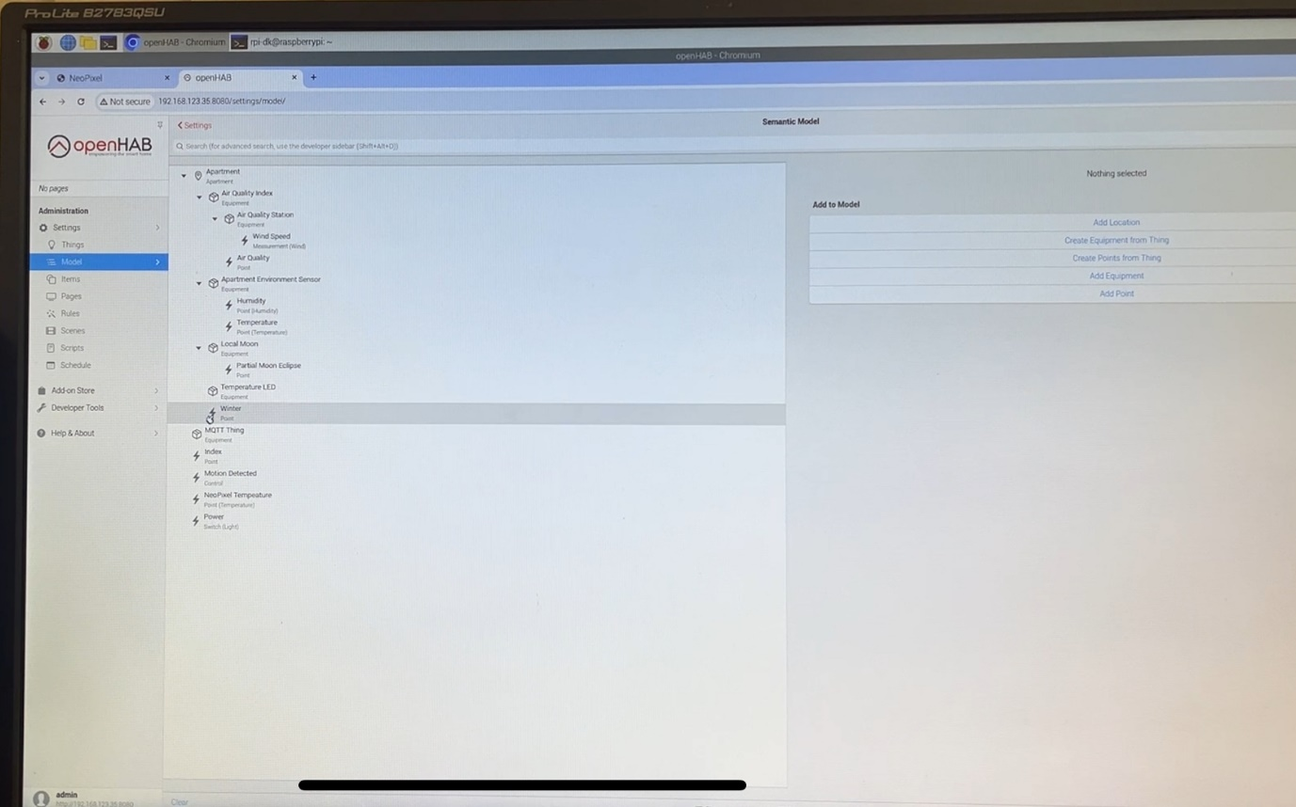

# OpenHAB

## Bindings Installed

* MQTT Binding: For communication with ESP8266 and NeoPixel LED.
* OpenWeatherMap Binding: For weather and UV index.
* Air Quality Binding: To fetch Air Quality Index.
* Astro Binding: For sun and moon data.
* WiFi LED Binding: Manages NeoPixel LED Strip.

## Things

|  |  |  |
| --- | --- | --- |
| Thing Name | Type | Description |
| MQTT Broker | MQTT Thing | Central communication hub. |
| LED MQTT Thing | Generic MQTT Thing | Controls NeoPixel LED. |
| Motion MQTT Thing | Generic MQTT Thing | Tracks motion via PIR sensor. |
| Humidity MQTT Thing | Generic MQTT Thing | Monitors humidity via DHT11. |
| Air Quality API | Generic MQTT Thing | - |
| Air Quality Station | Generic MQTT Thing | - |
| NeoPixel Thing | Generic MQTT Thing | - |
| Local Sun and Moon | Generic MQTT Thing | - |

## Items

|  |  |  |  |
| --- | --- | --- | --- |
| Item Name | Type | Linked Thing | Purpose |
| Apartment Temperature | Number:Temperature | Humidity MQTT Thing | Tracks temperature. |
| Apartment Humidity | Number:Dimensionless | Humidity MQTT Thing | Tracks humidity. |
| Motion Detected | Switch | Motion MQTT Thing | Detected the movement. |
| Air Quality Index | Number | Air Quality API | Tracks air quality. |
| Wind Speed | Number | Air Quality Thing | Calculate wind speed. |

## Rules and Scripts

Temperature: It warns the resident in case the temperature rises above 24°C or falls below 14°C. It also sends evacuation warnings if the temperature goes above 70°C.

Humidity: In case of humidity above 75%, it warns the resident to check for any source, such as a boiling kettle.

Motion: It monitors the movement inside the apartment and warns the warden if no movement is detected before 11 AM.

Air Quality Index: It sends a warning to the warden when AQI exceeds the safe limit.

See the Appendices.

## User Interface

The user interface is implemented using OpenHAB's Semantic Model and custom Pages. It displays the following data on the Warden's Office Dashboard:

* Current temperature and humidity.
* Motion detection status.
* LED visual indicators for temperature changes.
* Real-time AQI and weather data.

## **Advanced Features for Future Implementation**

1. **UV Index Monitoring with NeoPixel LED Alert**

The project seeks to protect elderly residents against harmful UV exposure during summer. It does so by embedding the IoT prototype with a UV monitoring feature. This feature sends warnings to both the residents and wardens if the UV level is too high-UV > 6 ̄, and simultaneously when the outside temperature is too high-for instance, > 35°C. Since the purchase of a dedicated UV sensor is out of the project budget, this data is retrieved via the OpenWeatherMap API or other similar services.

Besides that, the system gives a visual cue using NeoPixel LEDs:

• Red: High UV index or temperature

• Blue: Safe UV and temperature levels

**NeoPixel LED UV Monitoring Rule**

Following is the code for an OpenHAB rule that integrates UV index and temperature monitoring with a NeoPixel LED system.

**Implementation Steps**

1. Create and Configure Items

In OpenHAB, define the items UV_Index and Outdoor_Temperature. Example:

Code:

Number UV_Index "UV Index [%.0f]" {channel="openweathermap:uvindex:local:uvindex"}

Number:Temperature Outdoor_Temperature "Outdoor Temperature [%.1f °C]" {channel="openweathermap:weather-and-forecast:local:temperature"}

2. Link NeoPixel LEDs to MQTT

Ensure your NeoPixel LED controller subscribes to the topic NeoPixel/LEDStrip/cmd. Configure this in your ESP8266 or relevant device with the following MQTT format:

* Topic: NeoPixel/LEDStrip/cmd
* Payload examples:
* "solid,FF0000,100" (Red, Full Brightness)
* "solid,0000FF,100" (Blue, Full Brightness)

3. Bindings

Install and configure the following bindings:

* OpenWeatherMap Binding: To fetch UV index and outdoor temperature.
* MQTT Binding: For communication with NeoPixel LEDs.

4. Test the Rule

Simulate UV and temperature changes in OpenHAB:

* Manually set UV_Index and Outdoor_Temperature values in the UI.
* Observe changes in LED color and notifications.

Rule :

rule "UV and Temperature Monitoring"

when

Item UV_Index changed or

Item Outdoor_Temperature changed

then

val uv = (UV_Index.state as Number).intValue

val temp = (Outdoor_Temperature.state as QuantityType<Number>).floatValue

val mqttActions = getActions("mqtt", "mqtt:broker:careHome")

if (uv > 6 || temp > 35) {

// High UV or Temperature: Set NeoPixel LED to Red

mqttActions.publishMQTT("NeoPixel/LEDStrip/cmd", "solid,FF0000,100", true)

sendBroadcastNotification("Warning: High UV Index or Temperature! Avoid prolonged outdoor exposure.")

} else {

// Safe conditions: Set NeoPixel LED to Blue

mqttActions.publishMQTT("NeoPixel/LEDStrip/cmd", "solid,0000FF,100", true)

}

End

1. **Motion Detection Warning**

A rule can be created to alert the warden if no motion is detected in the apartment by 11 AM:  
code:

rule "No Motion Detected Alert"

when

Time cron "0 0 11 * * ?" // Runs daily at 11 AM

then

if (Apartment_Motion.state == OFF) {

sendBroadcastNotification("No motion detected in the apartment by 11 AM. Please check on the resident.")

}

End

1. **Identify Warden on Duty**

RFID tags or BLE beacons can detect warden presence:

* Sensors: Use ESP8266 or Raspberry Pi with BLE capabilities.
* Action: Update a Warden_On_Duty item when presence is detected.

Rule:

rule "Update Warden on Duty"

when

Item Warden_RFID changed

then

Warden_On_Duty.postUpdate(Warden_RFID.state.toString)

sendBroadcastNotification("Warden on duty: " + Warden_RFID.state.toString)

end

1. **Custom UI Enhancements**

Create additional widgets in the OpenHAB UI to display the following information: UV Index and temperature trends. The current warden on duty. Inactivity or dangerous condition alerts.

*Improved User Interface*

Objective: To extend the functionality of OpenHAB UI by including data and dynamic visualizations based on desirable functional requirements.

Procedure:

1. Pages: Add a page, Warden's Office, using OpenHAB's UI editor.
2. Widgets:

* UV Index Widget: A UV Index and temperature trend with dynamically colored coding.
* Motion Status Widget: real-time status on motion detection.
* Warden Duty Widget: provides the name or ID of the current warden on duty.

1. Example YAML for UV and Temperature:

Code: component: oh-chart

config:

period: 24h

series:

- entity: UV_Index

color: red

name: UV Index

- entity: Outdoor_Temperature

color: orange

name: Temperature

# Research and Alternatives

As mentioned, the proposed solution leverages cost-effective and open-source technologies. Herein, a small comparison of used technologies with alternatives is performed:

|  |  |  |  |
| --- | --- | --- | --- |
| Feature | Implemented Solution | Alternatives | Notes |
| Temperature Monitoring | DHT11 via ESP8266 | Dedicated ZigBee Sensors | ZigBee has better range but higher cost. |
| UV Index Data | OpenWeatherMap API | Dedicated UV Index Sensors | OpenWeatherMap is free and sufficient for proof-of-concept. |
| Motion Detection | PIR Sensor via MQTT | WiFi Cameras | Cameras offer more accuracy but invade privacy. |
| Warden Presence | BLE/RFID | Manual Logging | BLE/RFID is more automated. |

# Conclusion

The proposed IoT prototype addresses essential requirements for monitoring and safety within the care home. Using low-cost hardware and open-source software ensures affordability while maintaining scalability for future enhancements. By integrating advanced features, the system demonstrates significant potential to improve residents' quality of life and simplify warden operations.

In the future, we will implement advanced features like UV monitoring using OpenWeatherMap's UV index and Astro Binding, along with visual temperature alerts via the NeoPixel LED strip. These will further enhance the system's ability to address specific risks for elderly residents, such as UV exposure and sudden temperature changes. Due to system corruption in the initial development process, these features could not be implemented in the current prototype but will be a priority for the next iteration. This proof of concept illustrates the transformative power of IoT solutions in residential care settings.

# Appendices

## NeoPixel Screenshots:

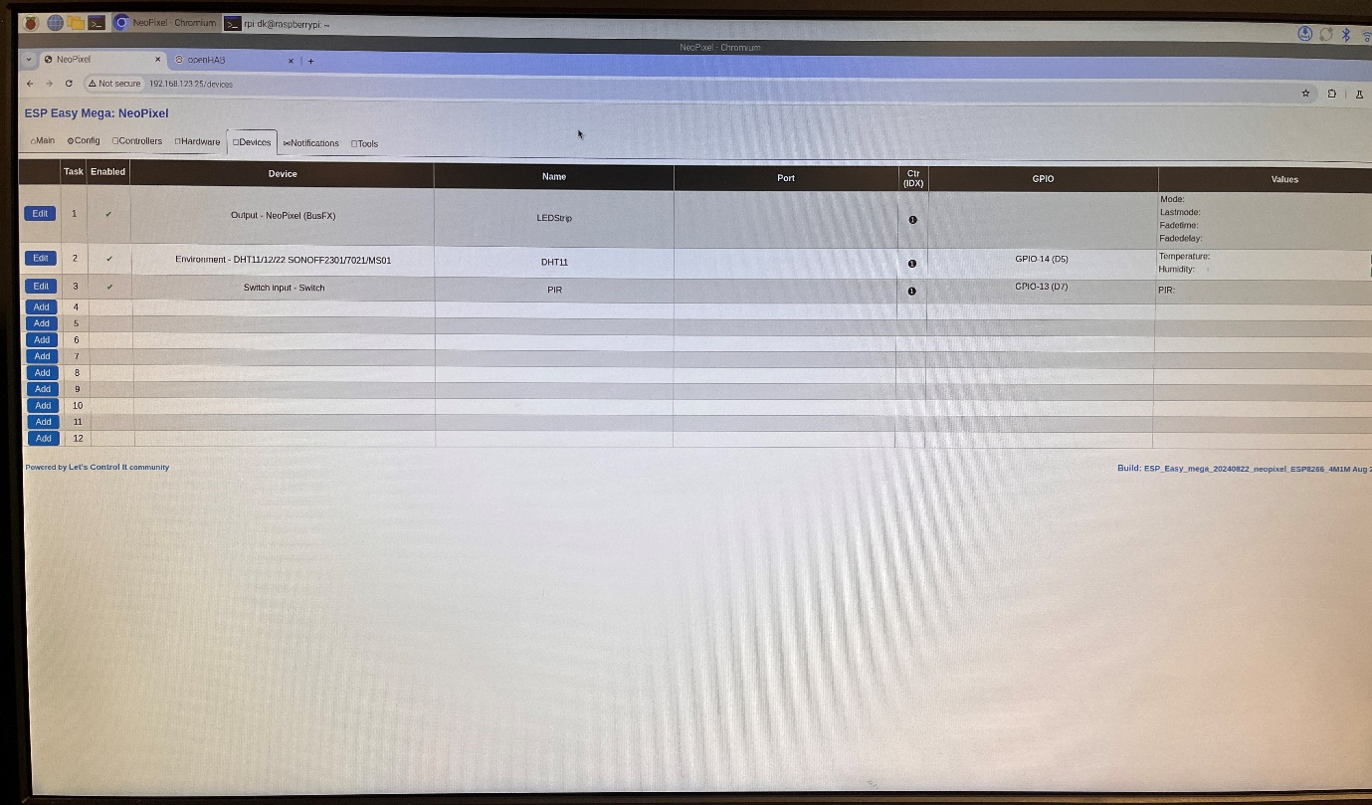

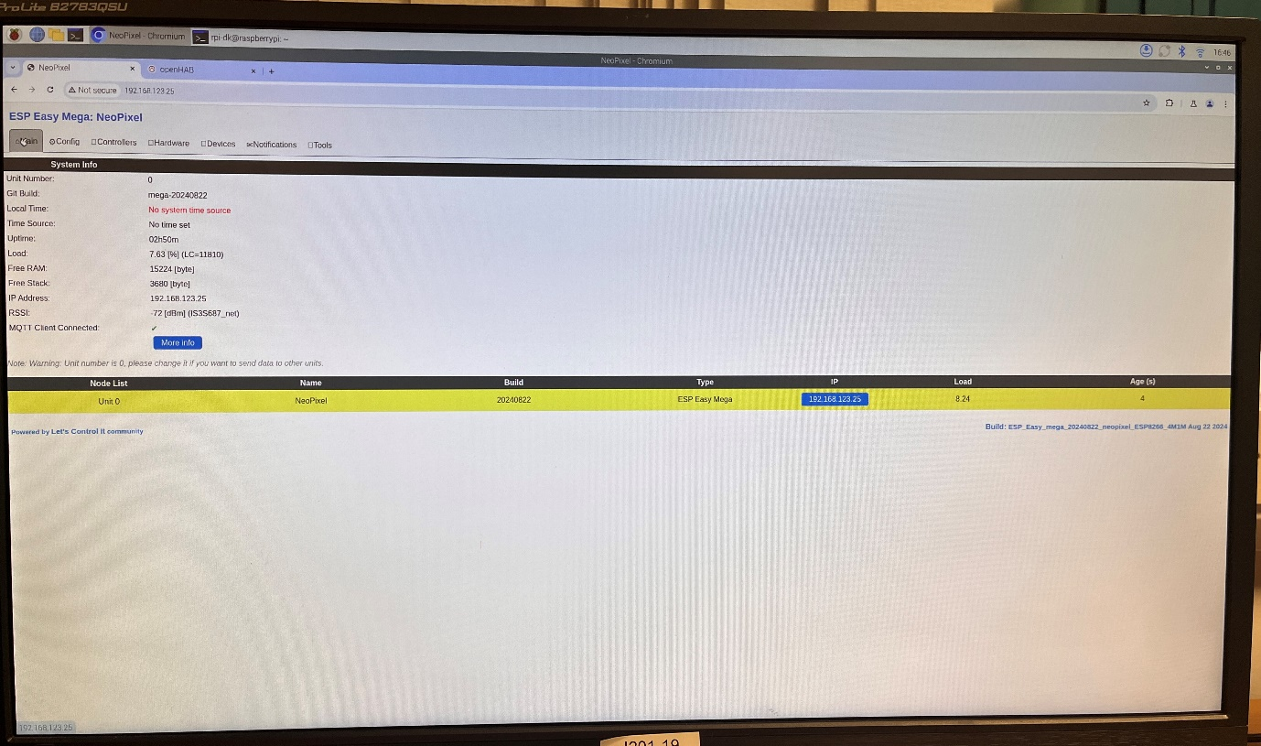

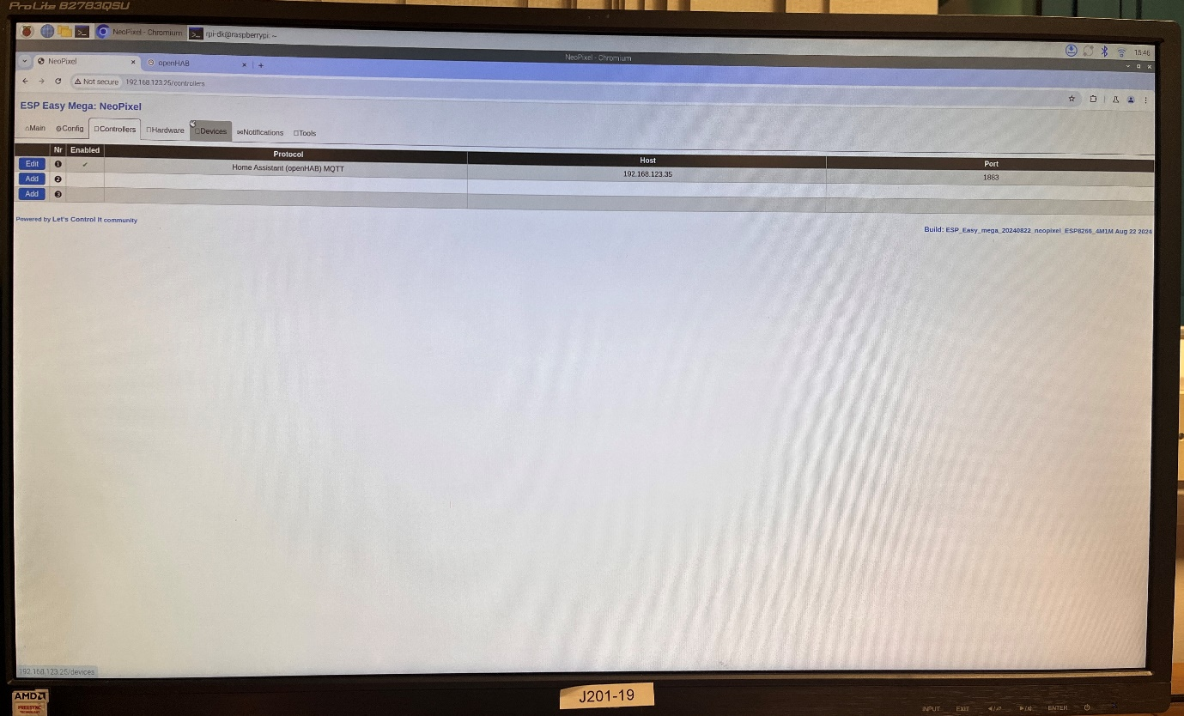

## OpenHab Screenshots:

**Binding**

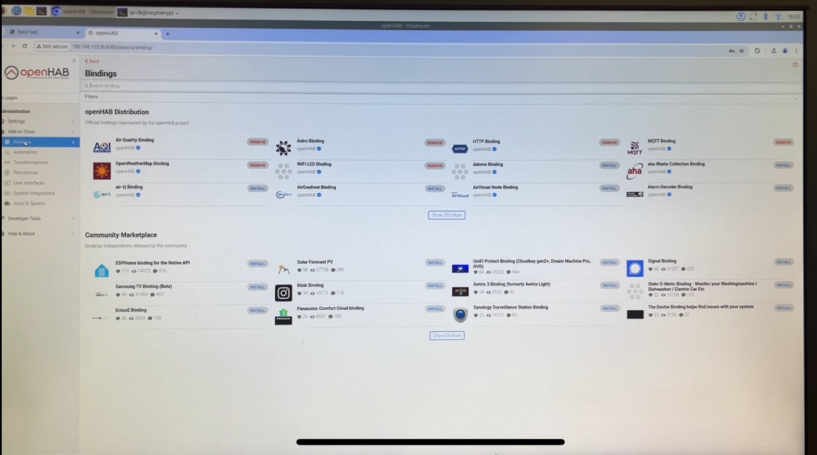

**Warden Office User interface:**

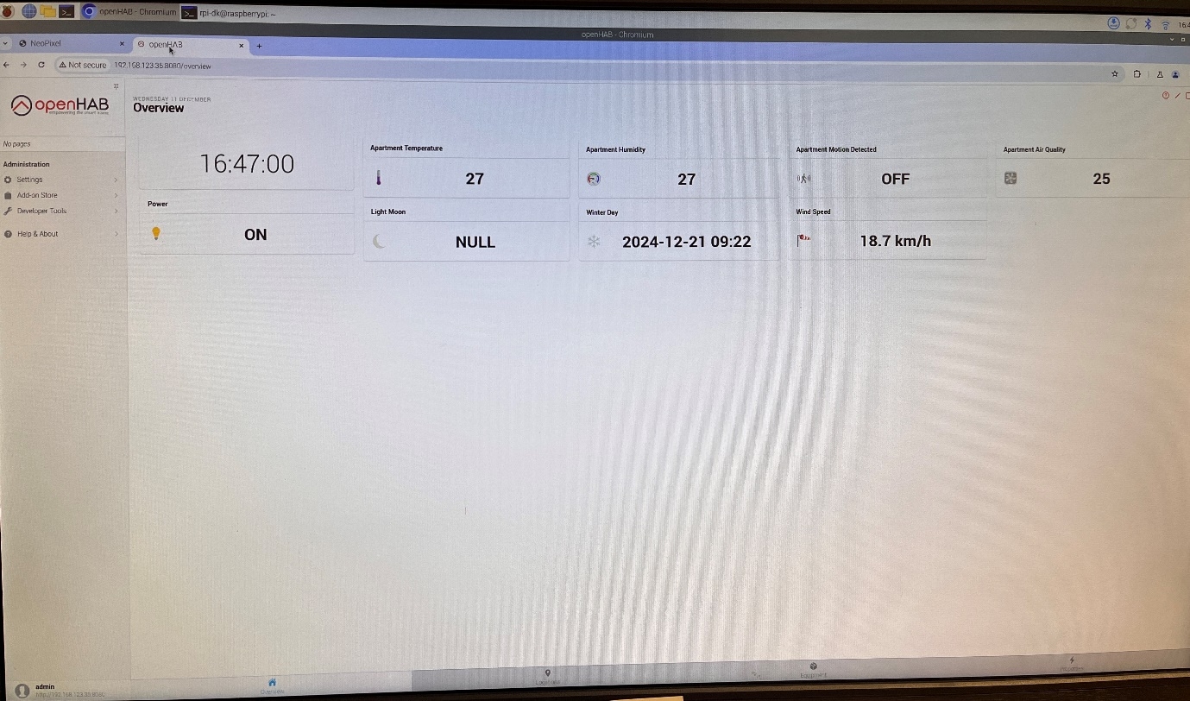

**Thing Creation:**

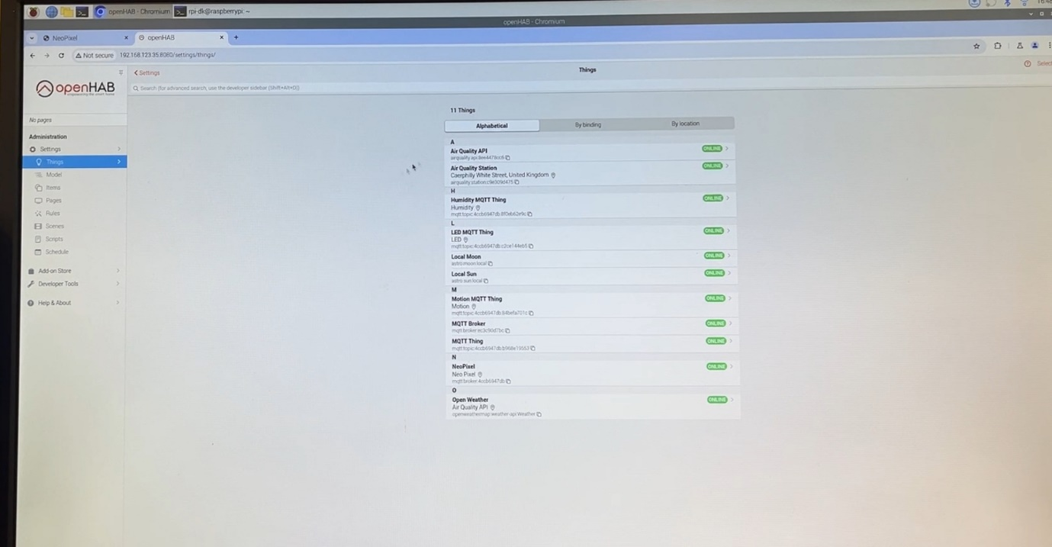

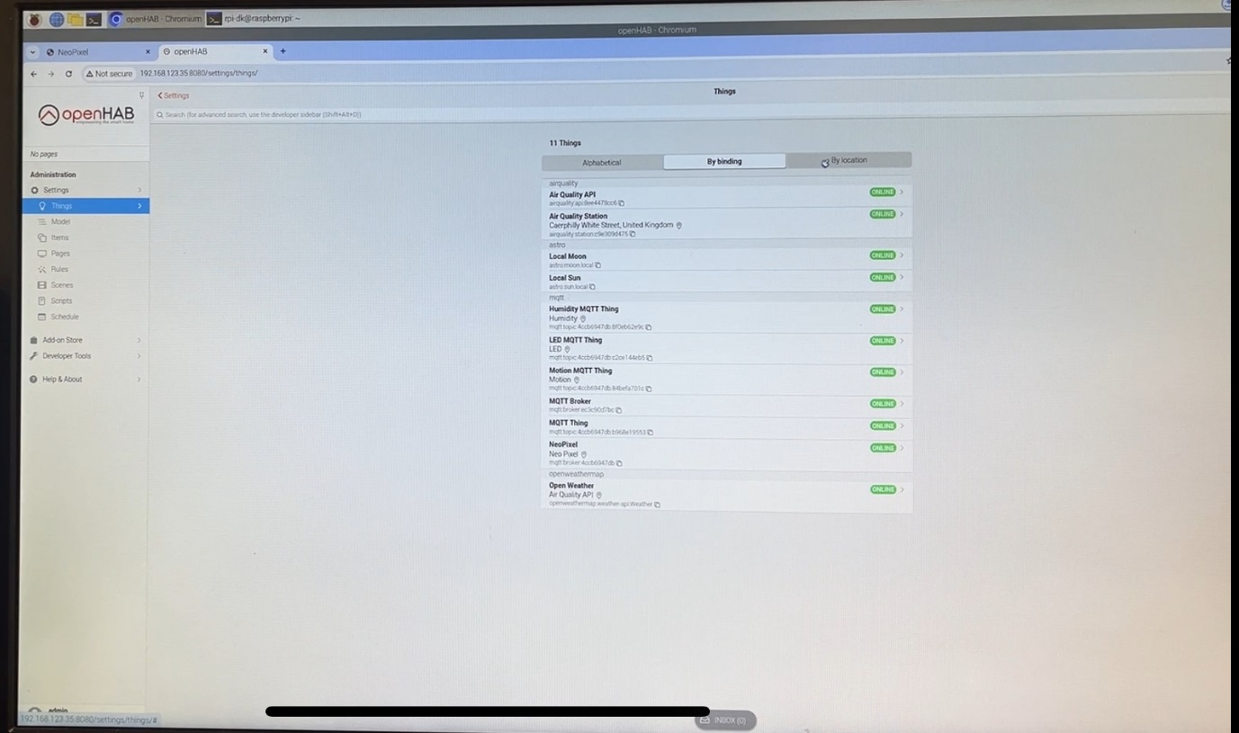

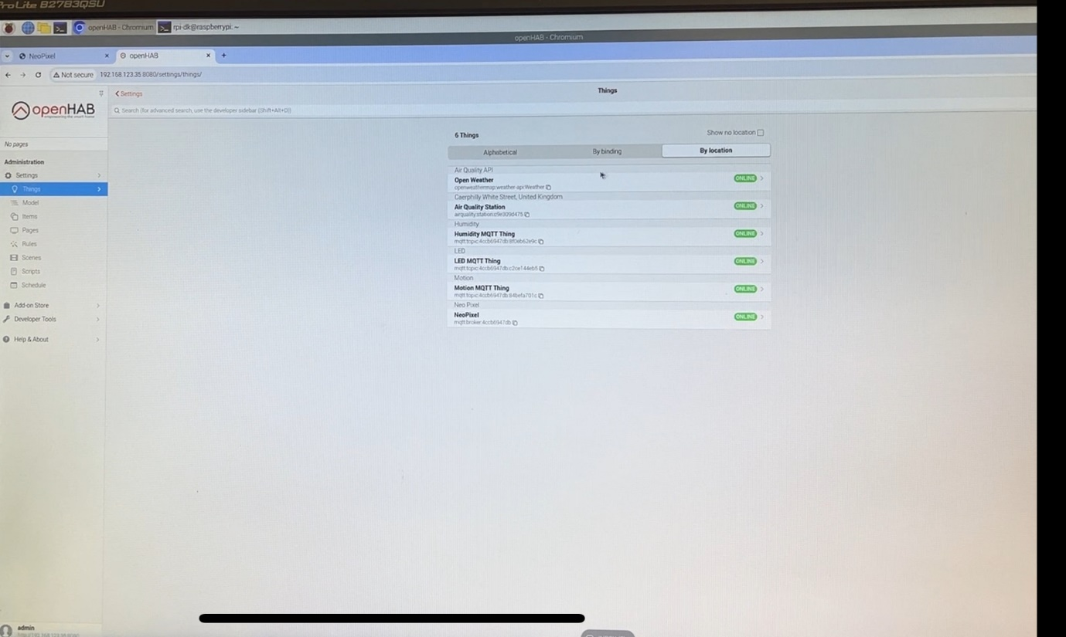

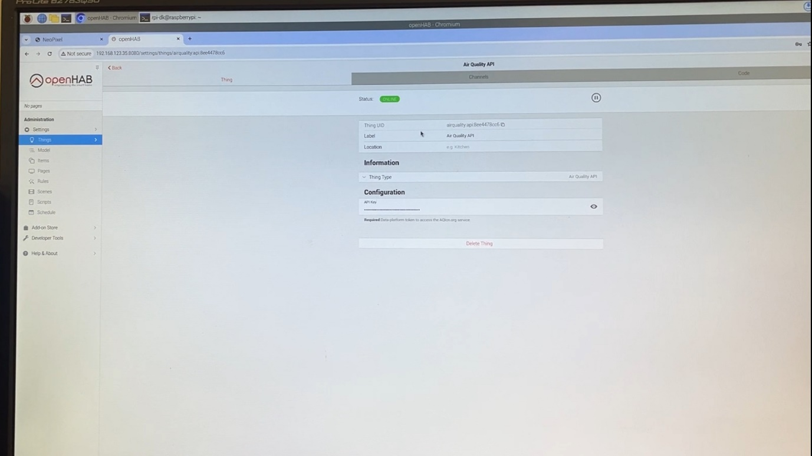

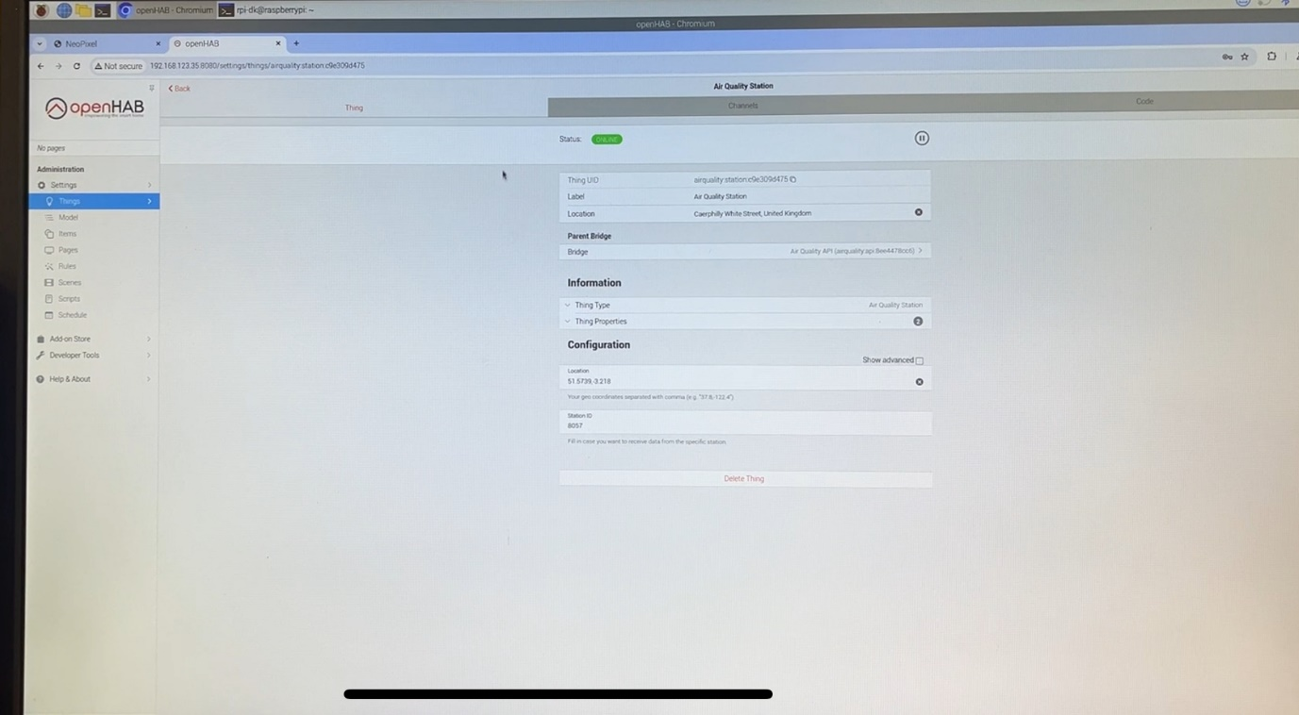

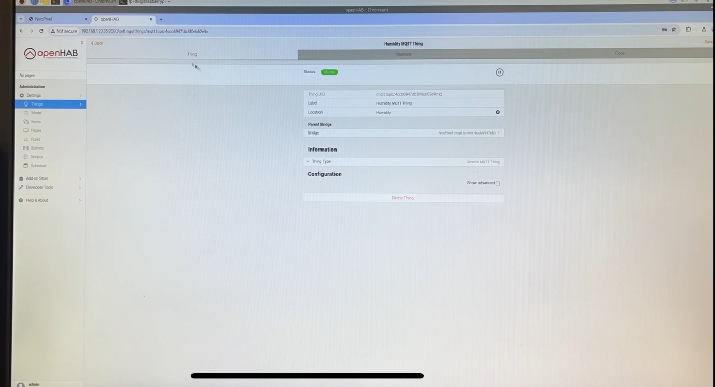

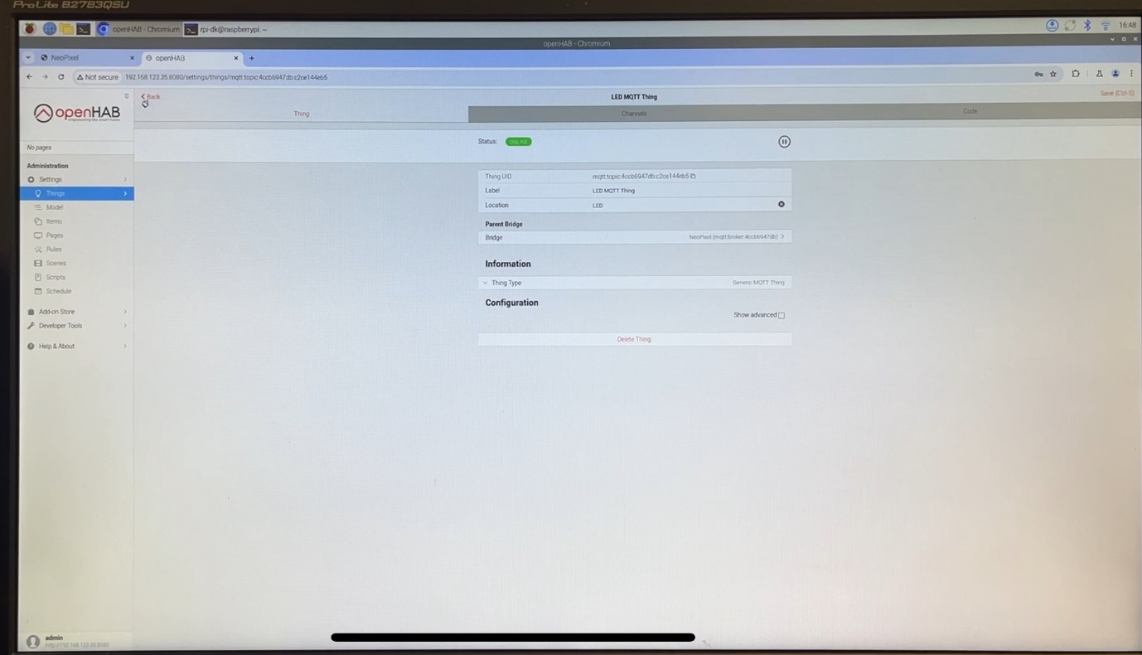

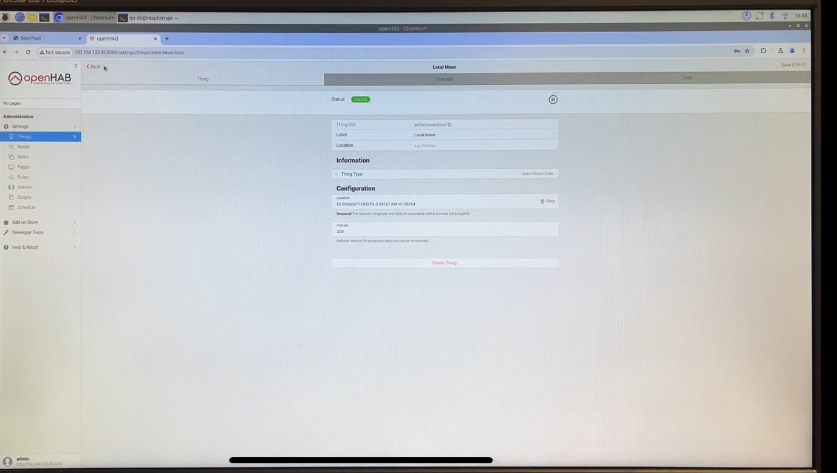

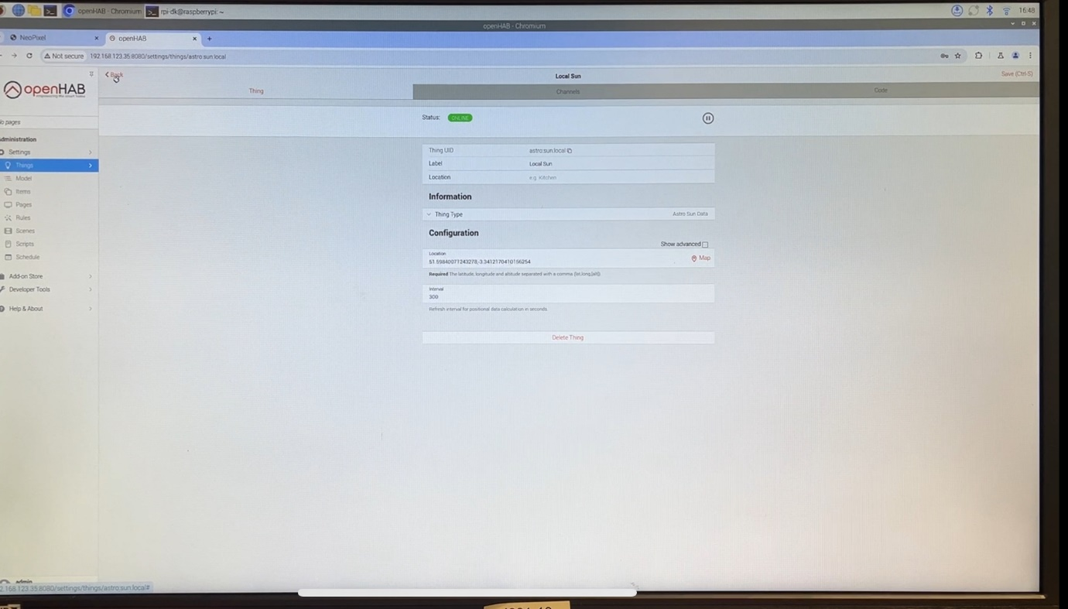

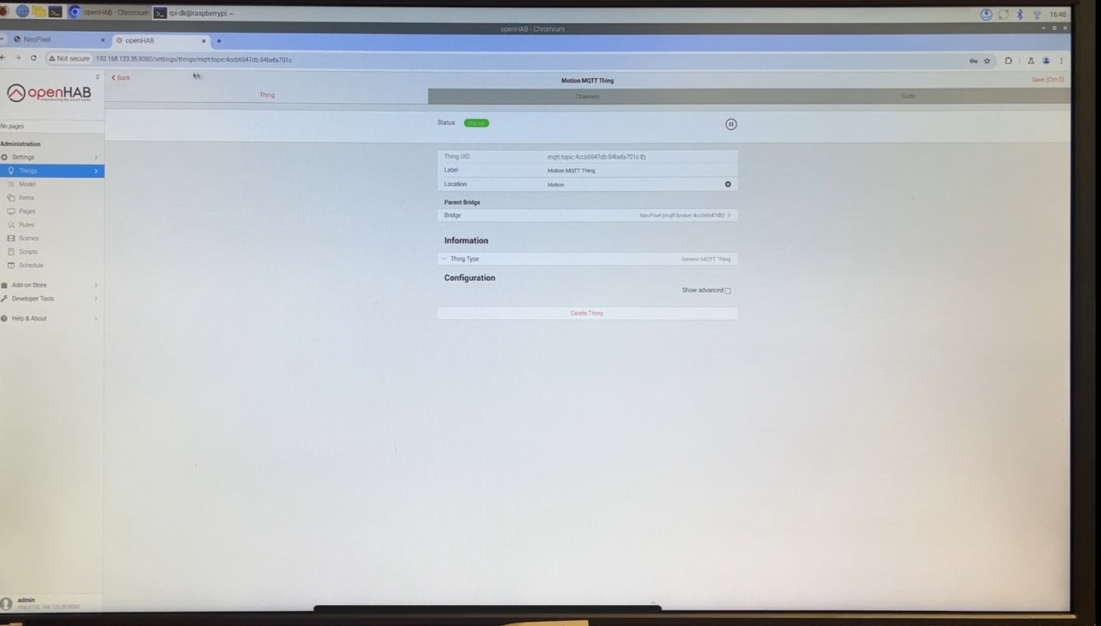

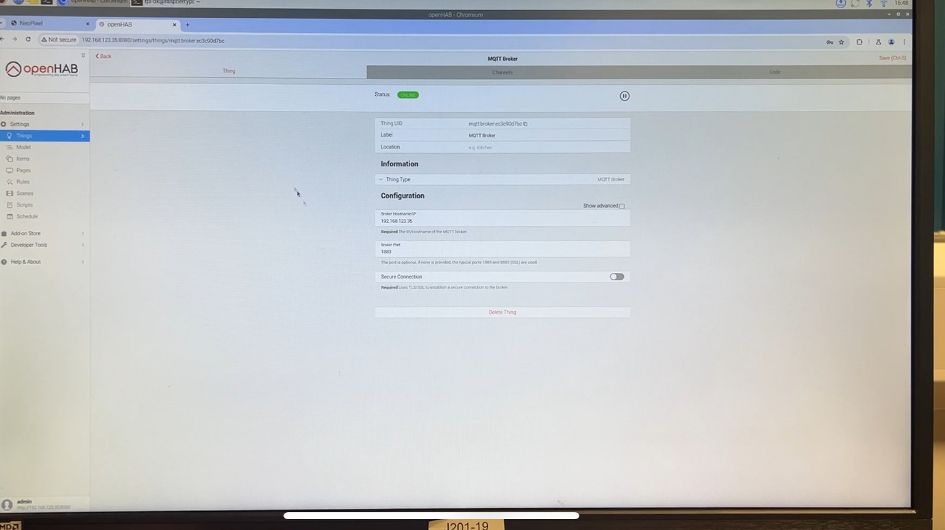

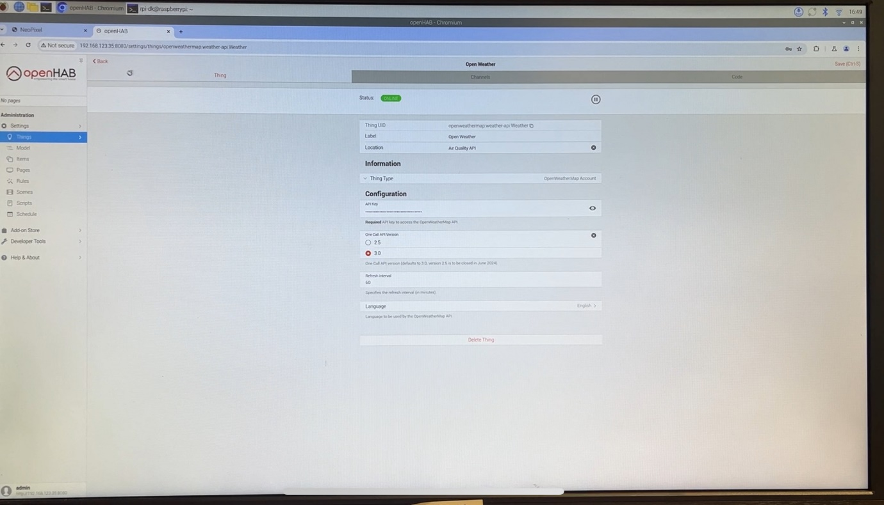

**Item Creation:**

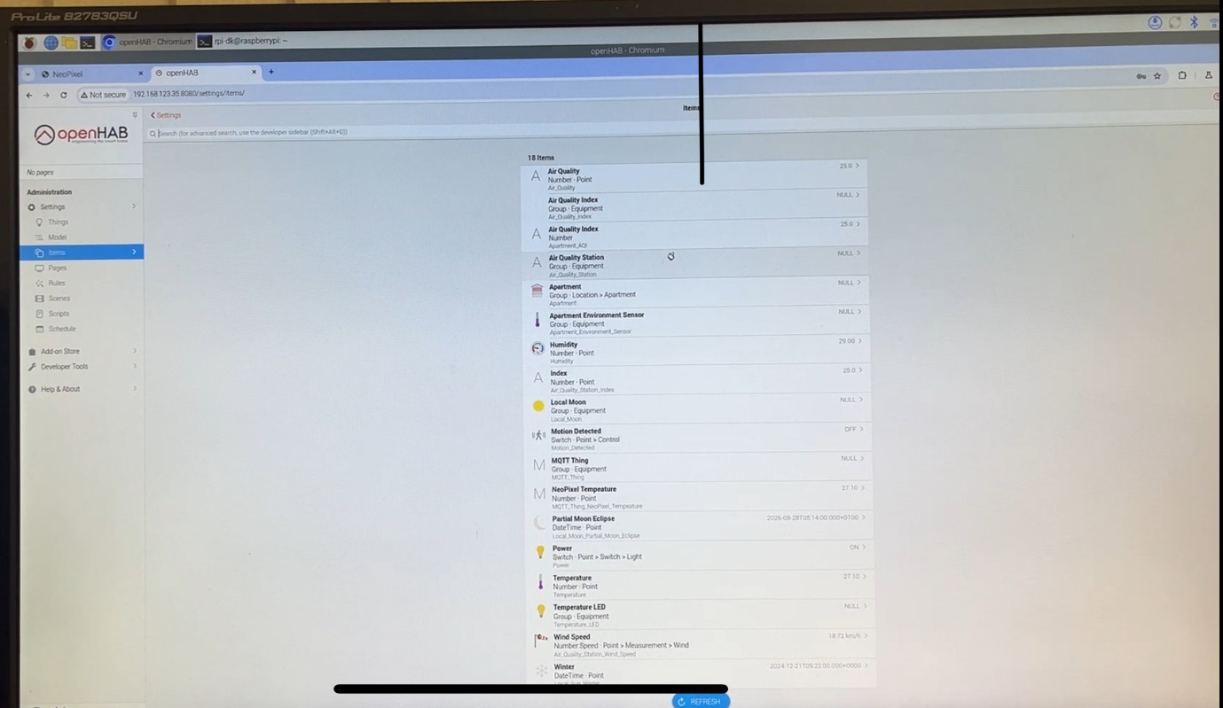

**Rules:**

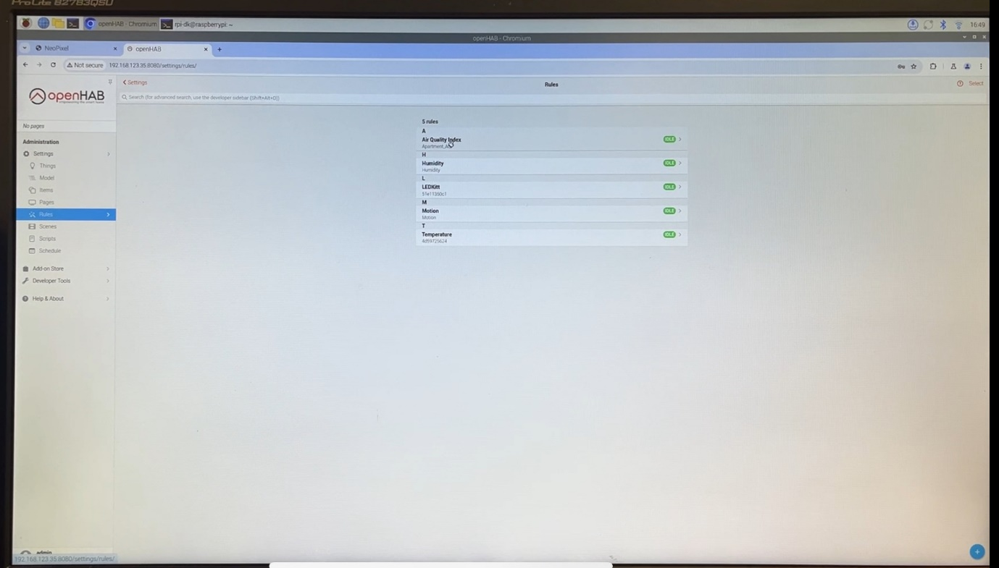

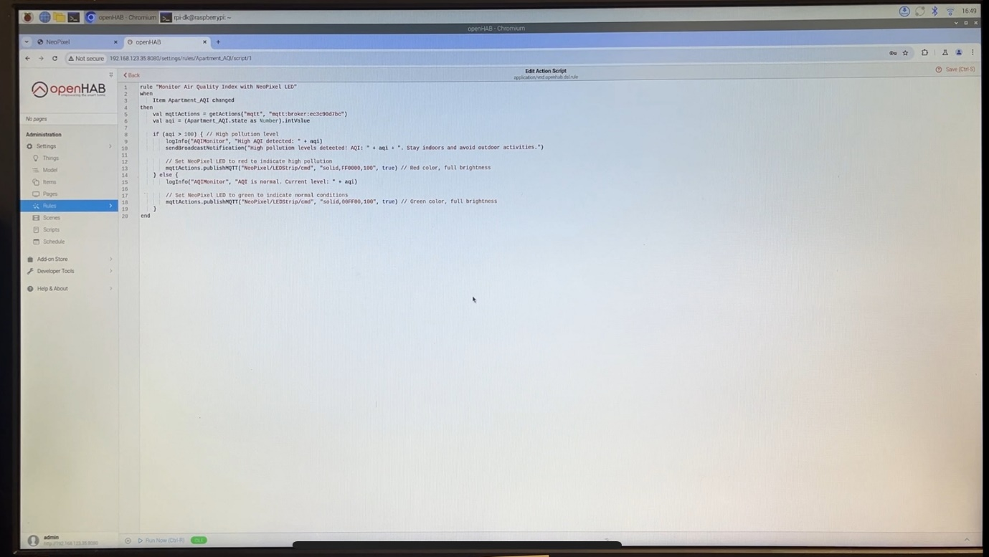

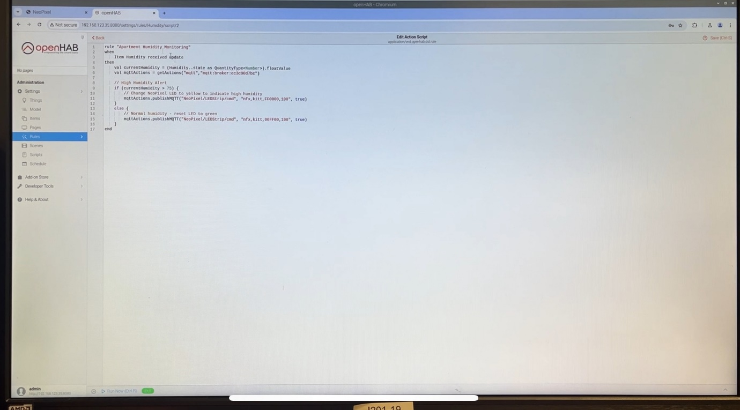

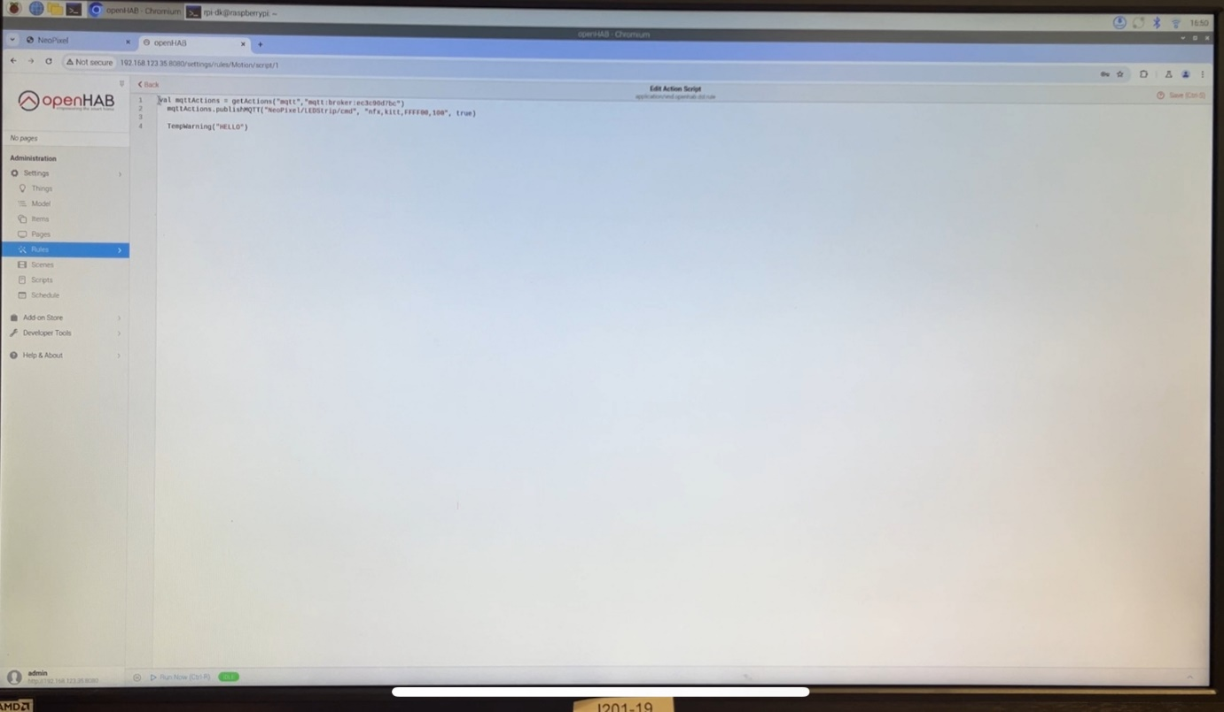

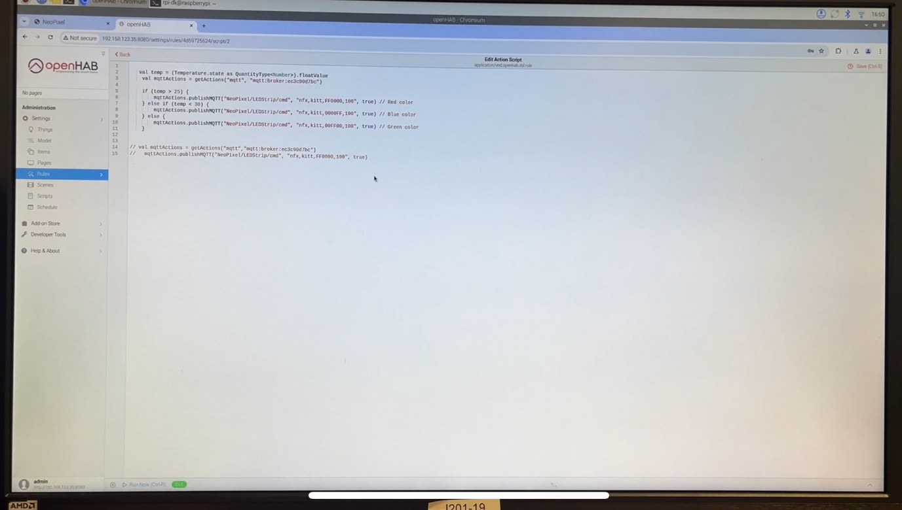

**User Interface:**

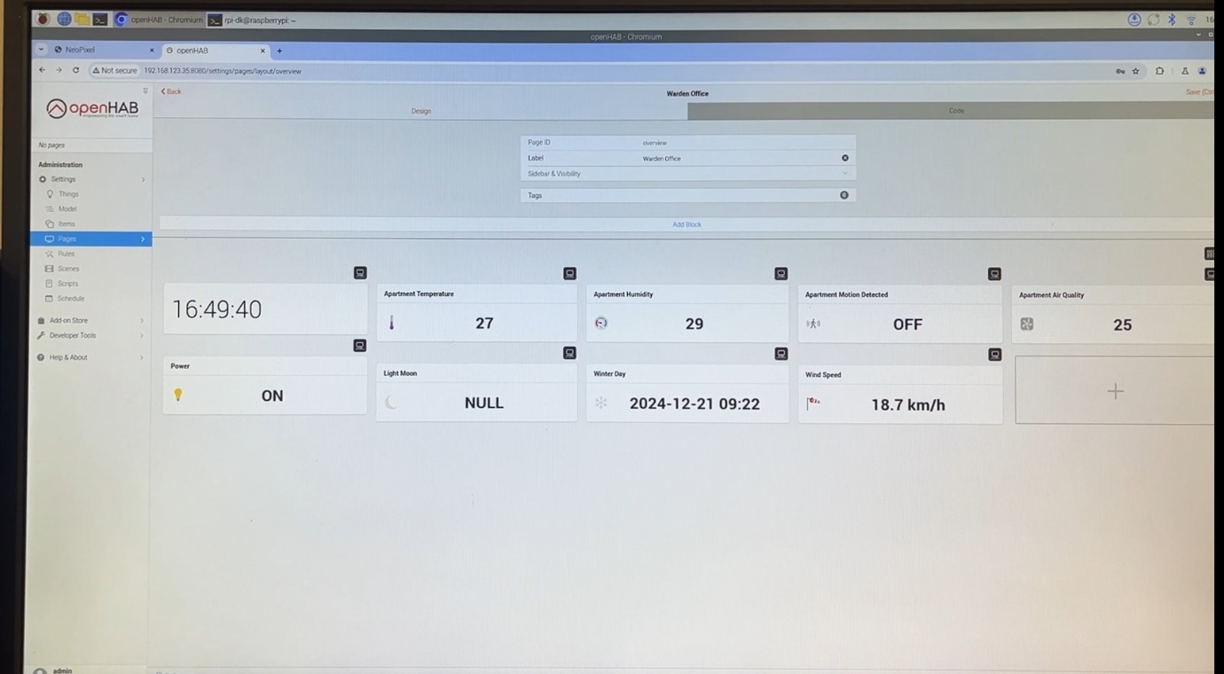



# Reference

Page (2021). *openHAB 3 Pages explained | Layout Page openHAB | Full openHAB 3 Setup Guide*. YouTube. Available at: https://youtu.be/EDVWbkelRTY?si=QmEr5VfY9j2bHW_E [Accessed 07 Dec. 2024].

in (2021). *5 Top Functions in openHAB 3 | SmartHome Tipps | Card Background | openHAB Tutorial English*. [online] YouTube. Available at: https://youtu.be/EPIRGFd3mlw?si=PP_g6PBHpvuNE6em [Accessed 09 Dec. 2024].

‌

‌